**PROJECT REPORT**

**Diwali Sales Analysis Report**

**Project Title :** Diwali Sales Analysis

**Language :** Python

**Libraries :** Nympy,Pandas,Matplot,Seaborn

## ****Introduction****

This report provides insights into sales data, focusing on customer demographics, product categories, regional sales, and purchasing behavior. The analysis helps to identify customer profiles, product preferences, and regional sales performance, which can guide strategic business decisions.

## ****Data Overview****

The dataset used in this analysis includes information on customer demographics, product details, order amounts, and more. The data contains several columns, such as:

* **User_ID**: Unique customer identifier
* **Cust_name**: Customer name
* **Product_ID**: Unique identifier for products
* **Gender**: Customer gender
* **Age Group**: Age group classification
* **Marital_Status**: Marital status of the customer
* **State**: Customer's state of residence
* **Occupation**: Customer's occupation
* **Product_Category**: The category of the product
* **Orders**: Number of orders placed by the customer
* **Amount**: Total amount spent by the customer

### **Data Cleaning**

The dataset was cleaned by removing unnecessary columns, such as 'Status' and 'unnamed1', and handling missing values. The data type of the "Amount" column was changed to int for consistency.

### **Data Summary**

* Shape of the data: (rows, columns)
* Columns: List of all columns
* Descriptive statistics: Summary statistics for numerical columns (e.g., mean, median, standard deviation).
* **Exploratory Data Analysis (EDA)**

### **Gender vs Amount**

We analyzed the total amount spent by gender. The bar chart below visualizes the comparison between female and male customers in terms of purchasing power.

#### **Gender vs Amount**

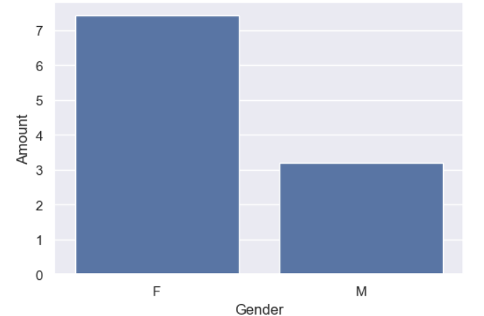

**Insights**:

The graph shows that the majority of the buyers are females, and their purchasing power is higher than that of males.

### **Total Amount vs Age Group**

We analyzed the total amount spent by customers across different age groups.

#### **Total Amount vs Age Group**

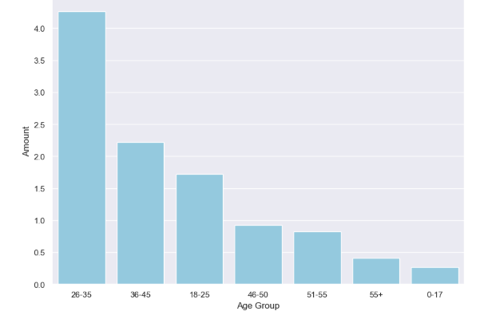

**Insights**:

* The majority of buyers are in the 26-35 years age group, and the least are from the 0-17 age group.

### **State vs Orders**

We examined the total number of orders placed by customers from different states.

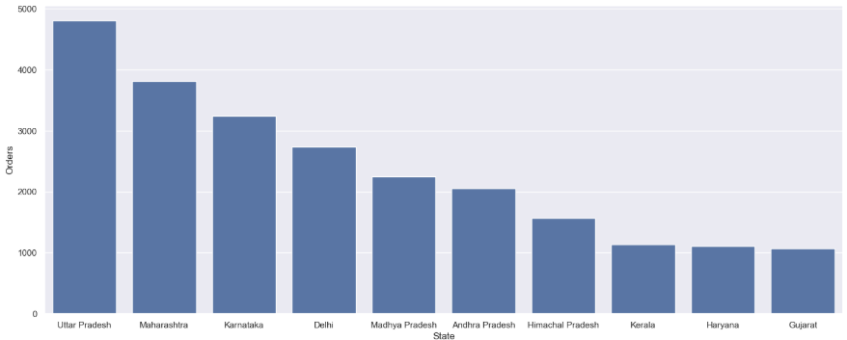

**Insights**:

* Uttar Pradesh has the highest number of orders, while Gujarat has the least.

### **State vs Total Sales (Amount)**

We analyzed the total sales (amount) by state to understand regional performance.

#### **State vs Total Sales**

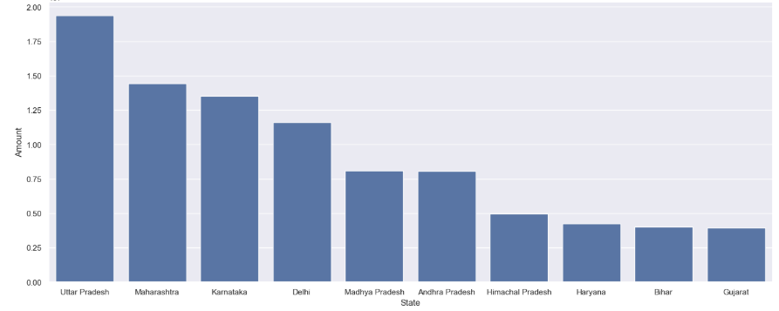

**Insights**:

* The highest sales are from Uttar Pradesh, Maharashtra, and Karnataka, with Uttar Pradesh leading in terms of total sales.

### **Marital Status and Gender vs Amount**

This analysis looks at the total amount spent by customers based on marital status and gender.

#### **Marital Status and Gender vs Amount**

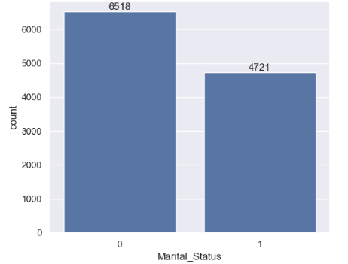

**Insights**:

* Most of the buyers are married women, and they also tend to have higher purchasing power compared to other groups.

### **Occupation Insights**

We examined the occupation of customers to identify trends in purchasing behavior.

#### **Most Common Occupations**

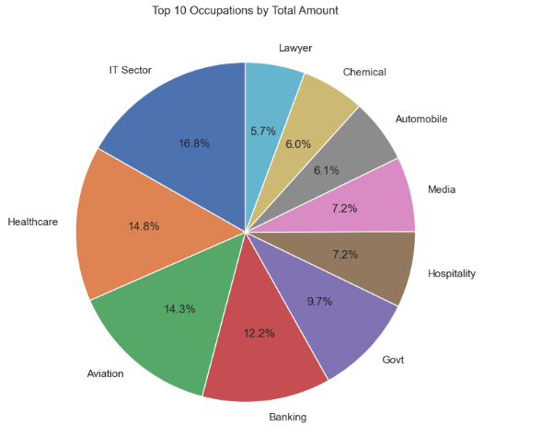

**Insights**:

* The most common occupations among buyers include those in the IT, healthcare, and aviation sectors.

### **Product Categories**

We identified the most popular product categories based on sales.

#### **Most Popular Product Categories**

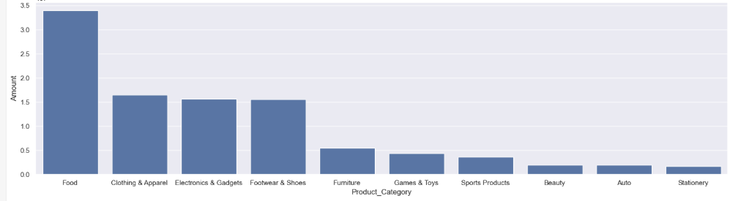

**Insights**:

* The most sold products are from the food, clothing, and electronics categories.
* **Customer Target Profile**

Based on the analysis, the ideal customer profile is as follows:

* **Age Group**: 26-35 years
* **Gender**: Female
* **Marital Status**: Married
* **Occupation**: IT, healthcare, and aviation sectors
* **Regions**: Uttar Pradesh (UP), Maharashtra, Karnataka

## ****Regional Sales Insights****

### **High Sales Regions**

* **Top Performing States**: Uttar Pradesh, Maharashtra, and Karnataka have the highest sales.

### **Low Sales Regions**

* **Low Performing States**: Haryana, Gujarat, and Bihar have comparatively lower sales.

Strategic efforts are recommended to boost sales in these regions.

## ****Frequently Bought Together Products****

### **Most Sold Products**

* **Product ID 1**: P00265242
* **Product ID 2**: P00110942
* **Product ID 3**: P00237542

These products are the most frequently bought by customers and could represent key product offerings.

### **Least Sold Products**

* The least sold products should be evaluated further for potential improvements in marketing or product offerings.

## ****Conclusion****

### **Customer Insights**:

* The ideal customer is a **married woman aged 26-35**, residing in states like **Uttar Pradesh**, **Maharashtra**, and **Karnataka**, and working in **IT, healthcare, or aviation sectors**.
* Customers show a strong preference for products in the **food**, **clothing**, and **electronics** categories.

### **Regional Insights**:

* Sales in states like **Haryana**, **Gujarat**, and **Bihar** are comparatively low, and efforts should be directed toward boosting sales in these regions.
* **Recommendations**
* **Targeting**: Focus marketing efforts towards **married women in the 26-35 age group**, especially in states like **UP**, **Maharashtra**, and **Karnataka**.
* **Product Focus**: Enhance the promotion of **food**, **clothing**, and **electronics** products.
* **Regional Strategy**: Implement campaigns and sales strategies in low-performing states such as **Haryana**, **Gujarat**, and **Bihar** to improve sales.